LESSON B3-4:
TOPIC
B3
STATIC VARIABLES
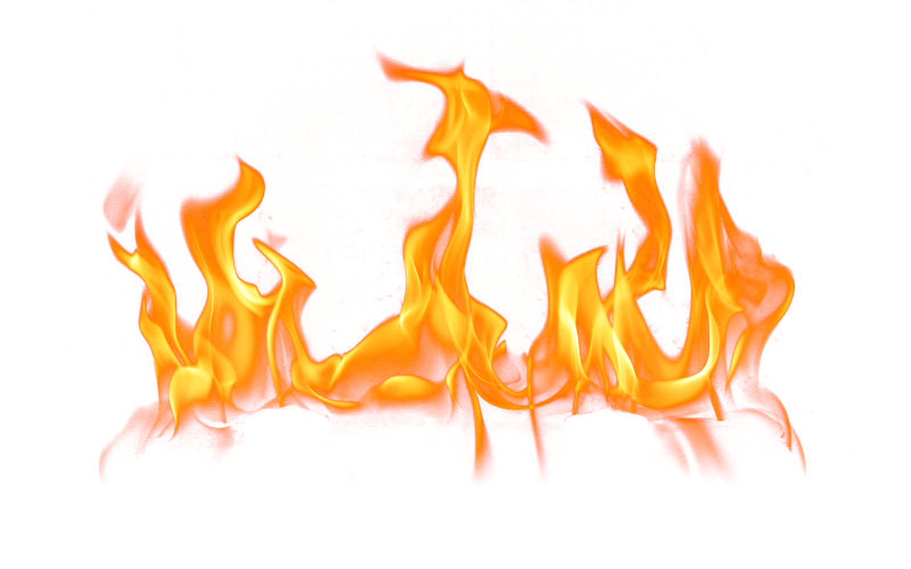
& FUNCTIONS
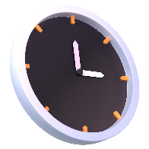
TIME TO COMPLETE: 1 HOUR

WARM UP QUESTION:
Explain why variables are generally private inside of a class:

WHAT YOU’LL NEED:
Pycharm

STATIC
Static – term used to

Do we need to create an object of the class to use a static variable or function?

STATIC INTERACTIONS
What are two reasons that static functions cannot access non-static variables?

If I have a static variable in a class, and a non-static (normal) function that modifies the static variable, will the static variable be modified for every instance of that class’s objects?

STATIC TO TRACK ID VARIABLES
How do we indicate a function or variable is static in UML?

How do we indicate a static variable in a Python script?

How do we indicate a static function in a Python script?

Copy/Paste your completed Product script into this word doc!

UMLAB
Correct the following UML diagram that’s a bit quirky:
MyClassName
+ attribute1
- attribute2: string
+ staticAttribute: int
+ getAttribute1(string): null
+ setAttribute1(): int
+ setStaticAttribute(int): void

Was there anything you weren’t sure about the change on?

